1

How to properly thread the primer connections into a Walbro carburetor (32, 37, and 39). I have made a detailed instruction.
Actually, we will need two nipples with m3 threads (photo 1), a drill bit 2.5mm and a tap m3 .
The length of the thread on the fittings is about 3mm.
Remove the carburetor. Unscrew the first cover. Try not to lose the screws. )
Drill a hole in the location shown in the photo (photo 2) and cut the thread. Screw in the plug on the thread locker (photo 3).
Further, in the place indicated on the photo (photo 4) using a heated wire make a hole with a diameter of about 3 mm (photo 5). It is not necessary to remove the diaphragm. If you have a plastic membrane, remove it and drill a hole in the specified place. Put the cover back in place (photo 6).
Photo1 Photo2
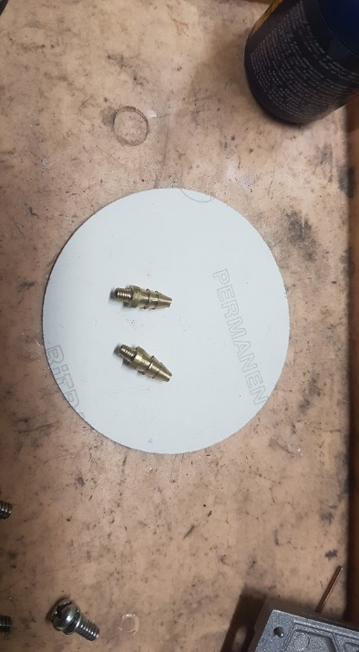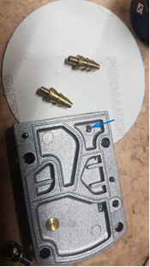
Photo3 Photo4
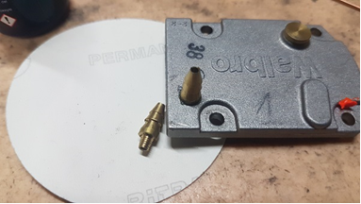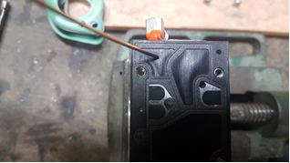

2

Photo5 Photo6
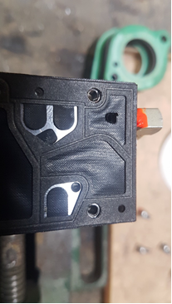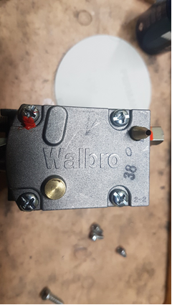
Remove the second cover. We very carefully remove the membrane (photo 7). On most carburetors on the membrane rod, there is a groove that enters the fork boxes (photo 8). Try to carefully free the membrane when removing the membrane from the fork of the rocker, so as not to bend the rocker. We unscrew the screw that holds the axis of the rocker. We remove the rocker. We pull out the spring. Attention! Spring, because it is a spring, loves to jump somewhere and hide, so the same we treat her extremely carefully :) (photo 9). Further, to drill holes in carburetor case, clamp the carburetor in a vice as showing in photo 10, so that the chips are spilled down when drilling. We drill hole. We use only a sharp drill. The surface for the holes are not flat, but with the radius, so if the drill is not sharp, it has everything the chances are somewhere to move out. Then, in the same position of the carburetor, cut the thread (photo 11).
We screw the fitting. (photo 12)

3

Photo7 Photo8
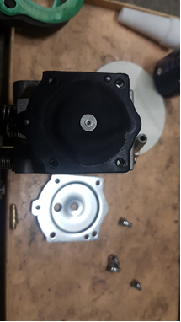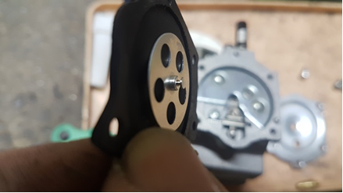
Photo9 Photo10
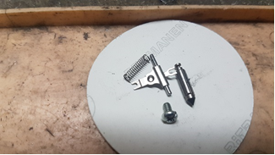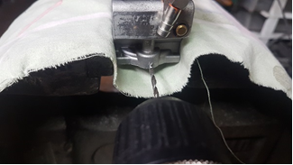
Photo11 Photo12
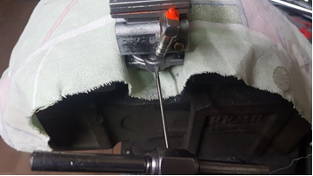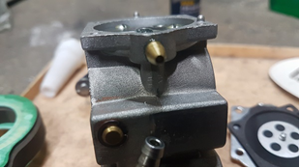

4

Remove any shavings that may have been left behind after
drilling and tapping inside the carburetor. Reassemble
back the rocker arm with the needle. Pay attention to the correct installation
spring (photo 13). Sometimes, when tightening the screw fixing the
kingpin, the spring moves a little aside from the centering protrusion on the kingpin.
of the rocker arm. Further, I usually check the tightness of the needle by pressurizing the carburetor inlet with the pressure on the carburetor inlet with my mouth and press the rocker arm several times.
(Do not forget to close the already cut in the first fitting). Put in place
membrane and cover in place. Put the carburetor in place, not forgetting to smear
thread locker on the bolts fixing the carburetor.
Connect the primer so that the fuel is injected into the second cut-in fitting.
How the primer works. When you press on the primer membrane, the fuel rises through the main fuel line and through the chamber in the carburetor enters the first fitting. Further fuel enters the primer and then through the second connection is injected into the carburetor through the injector in front of the air damper. The amount of fuel injected is selected for each engine individually. This amount, for the first time, can be controlled visually by removing the air filter. The primer itself is conveniently placed in a place on the frame, where it is convenient to reach by hand while sitting in the suspension. As a rule, it is a point in the lower third of the frame.

Photo13 Photo14
